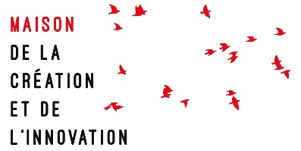

GATES (Grenoble ATtractiveness and ExcellenceS)
International Excellence in the Humanities Programme

Post-doctoral fellowships 2024-2026

Application form

CANDIDATE
First name
Last name
Date of birth
Nationality
Country of residence
Address
Email
Phone Number

CAREER
Academic discipline(s)
Current program/university and department (if relevant)
Current job title/employment (if relevant)

PROJECT
Title of proposal (in the language used for the project)
Summary of the research project
Collaborations (give details of the institutions, research teams or labs you would like to collaborate with and the nature of this collaboration)

Names and titles of two academic referees

Contact details of the referees (emails and phone numbers)

STAY AT THE MaCI
Planned date of arrival (between 15 September and 1 December 2024)

Specific needs or requests

This form must be sent with the requested documents to:

humanitiesfellowships@univ-grenoble-alpes.fr

